Deeptracking code installation
git clone (not need mention)
After all the environment dependences are installed
sudo python3 setup.py install
Code operation mode(required by the author)
Since the author imported the data mainly by the json file when running the project, the code is usually run like this mode : python xxxx.py -c xxxx.json
1)json file settings
First find the location of the relevant dataset combined with the author suggested in the json file to find the corresponding file link location.
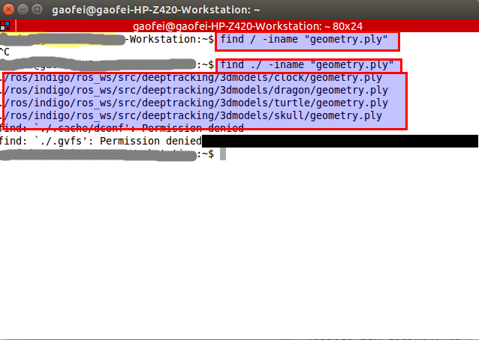
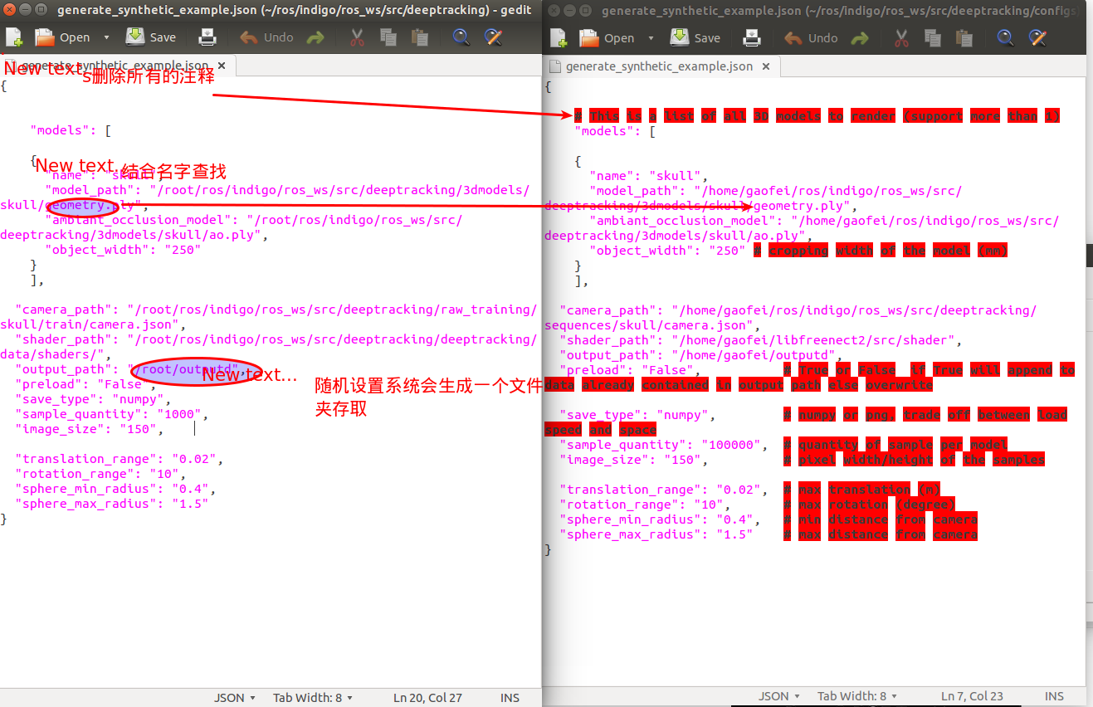
2)Replace plyparser
Since the author did not provide code for ply parsing , so readers need to replace the file bellow:

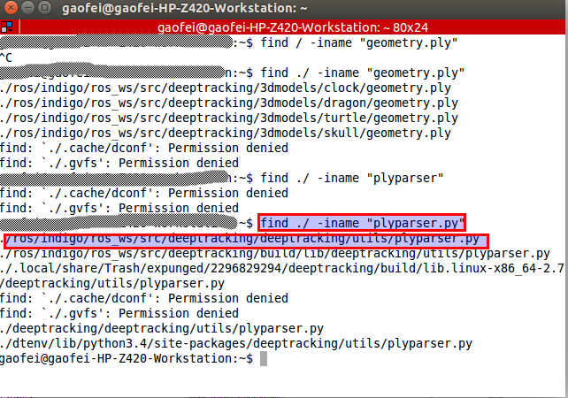
Transforms contain utility functions to manipulate pointclouds

date : 2017-20-03
"""

__author__ = "Mathieu Garon"
__version__ = "0.0.1"

from plyfile import PlyData, PlyElement
import os
import numpy as np
from PIL import Image

class PlyParser:
def __init__(self, path):
self.path = path
self.data = PlyData.read(path)

def get_texture(self):
for comment in self.data.comments:
if "TextureFile" in comment:
tex_path = os.path.join(os.path.dirname(self.path), comment.split(" ")[-1])
return np.array(Image.open(tex_path)).astype(np.uint8)
return None

def get_vertex(self):
for element in self.data.elements:
if element.name == "vertex":
return PlyParser.recarray_to_array(element.data[["x", "y", "z"]], np.float32)
raise KeyError("No field vertex with x, y, z in ply file.")

def get_vertex_color(self):
for element in self.data.elements:
if element.name == "vertex":
try:
return PlyParser.recarray_to_array(element.data[["red", "green", "blue"]], np.uint8)
except ValueError:
break
raise KeyError("No field vertex with red, green, blue in ply file.")

def get_vertex_normals(self):
for element in self.data.elements:
if element.name == "vertex":
try:
return PlyParser.recarray_to_array(element.data[["nx", "ny", "nz"]], np.float32)
except ValueError:
break
raise KeyError("No field vertex with normals nx, ny, nz in ply file.")

def get_texture_coord(self):
for element in self.data.elements:
if element.name == "vertex":
try:
return PlyParser.recarray_to_array(element.data[["texture_u", "texture_v"]], np.float32)
except ValueError:
break
raise KeyError("No field vertex with texture coord 'texture_u' and 'texture_v' in ply file.")

def get_faces(self):
for element in self.data.elements:
if element.name == "face":
try:
faces_object = element.data["vertex_indices"]
except ValueError:
break
# take for granted that all faces are of same lenght
faces = np.ndarray((len(faces_object), len(faces_object[0])), dtype=np.uint32)
for i, face in enumerate(faces_object):
faces[i, :] = face
return faces
raise KeyError("No field face with vertex_indices.")

@staticmethod
def recarray_to_array(array, type):
return array.view(type).reshape(array.shape + (-1,))

@staticmethod
def save_points(points, path):
vertex = np.zeros(points.shape[0], dtype=([('x', 'f4'), ('y', 'f4'), ('z', 'f4')]))
vertex.fill(255)
vertex['x'] = points[:, 0]
vertex['y'] = points[:, 1]
vertex['z'] = points[:, 2]
el = PlyElement.describe(vertex, 'vertex')
PlyData([el], text=ascii).write(path)

So far all the basic operation of the project is to complete the introduction.
Standard original, declined reproduced, if necessary, please contact the author: Myzhencai@hotmail.com

